Multiple-choice section

Question 1 [2.1]

Which of the following are multiples of 24?

A 24, 48 72, 96 B 24, 25, 26, 27 C 2, 4, 6, 24 D 21, 22, 23, 24

Question 2 [2.2]

The first five prime numbers are:

A 1, 2, 3, 5, 7 B 0, 1, 3, 5, 9 C 2, 3, 5, 7, 11 D 1, 2, 3, 4, 5

Question 3 [2.4]

Which statement is correct?

A 3 < 2 B -5 < 4 C 4 > 8 D -6 < -10

Question 4 [2.5]

Calculate the following: 7 – 3 – 6

A -2 B 2 C -16 D -16

Question 5 [2.1]

1365 is divisible by:

A 6 B 2 C 9 D 3

Question 6 [2.4]

Which set of numbers is in ascending order?

A 2, 1, 3, 8 B 7, 6, 2, 1 C -12, 8, 7, -2 D 2, 5, 7, 9

Question 7 [2.6]

Calculate: 9 – (-2)

A 11 B 7 C -7 D -11

Question 8 [2.7]

-8 – (-1) – (+2) simplifies to:

A -8 – 1 – 2 B 8 + 1 – 2 C -8 + 1 – 2 D 8 – 1 + 2

Question 9 [2.3]

The number 20 expressed as a product of its prime factors is:

A 2 × 5 × 4 B 2 × 2 × 5 C 1 × 2 × 10 × 20 D 2 × 10

Question 10 [2.2]

Which of the following is a composite number?

A 5 B 29 C 25 D 17

Question 11 [2.1]

The highest common factor (HCF) of 10 and 15 is:

A 12 B 6 C 5 D 14

Multiple-choice total marks: ____ / 11

Short answer section

Question 12 3 marks [2.1]

Complete the sentences about the divisibility test.

(a) A number is divisible by 2 if the last digit is an __________ number.

(b) A number is divisible by 8 if the number formed by the last _____ digits is divisible by 8.

(c) A number is divisible by 9 if the sum of the digits is divisible by ________.

Question 13 2 marks [2.2]

Explain what is meant by the term ‘co-prime’. Use an example to help you explain.

Question 14 3 marks [2.1]

Find the highest common factor for the following pairs of numbers.

(a) 18 and 20

(b) 42 and 56

(c) 15 and 30

Question 15 3 marks [2.1]

Determine which of the numbers 60, 81, 435 and 2892:

(a) are divisible by 2

(b) are divisible by 3

(c) are divisible by 5

Question 16 2 marks [2.1]

Sliced cheese comes in a packet of 15 and bread rolls come in a packet of 20. What is the least number of packets of each that can be bought to make cheese rolls and have no cheese or bread rolls left over?

Question 17 3 marks [2.2]

Fill in the missing prime numbers.

(a) 2, _________, 5, _______, 9

(b) _______, 23, _________, 31

(c) ________, 53, 59, __________, ___________

Question 18 1 mark [2.2]

List the composite numbers between 70 and 80.

Question 19 3 marks [2.2]

Which of the following pairs of numbers are co-prime. State your reasons.

(a) 14 and 15

(b) 14 and 21

(c) 15 and 28

Question 20 3 marks [2.3]

Draw a factor tree for the number 56, then express 56 as a product of its prime factors in index form.

Question 21 2 marks [2.3]

What number is the product of this prime factorisation?

23 × 33

Question 22 3 marks [2.4]

Write an integer that represents each of the following values.

(a) 3 °C below zero __________

(b) A bank deposit of $140 __________

(c) The river rose by 650 mm __________

Question 23 3 marks [2.4]

Write a > or < symbol between each pair of integers to make a correct statement.

(a) +11 __________ -8

(b) -7 __________ -3

(c) 0 __________ -1

Question 24 2 marks [2.4]

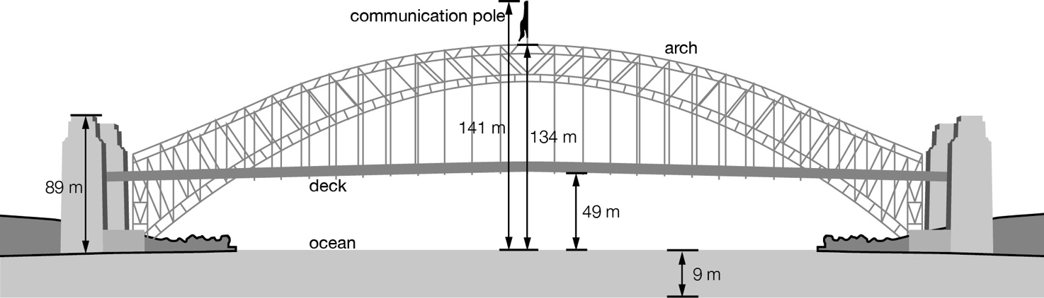

(a) What is the distance from the top of the arch to the bottom of the ocean?

(b) What is the distance from the top of the communications pole to the bottom of the deck?

Question 25 2 marks [2.5]

Use a number line to calculate -8 + 12.

Question 26 3 marks [2.5]

Calculate the following.

(a) 8 + 6 + 12

(b) -2 + 4 + 2

(c) 15 – 19 – 1

Question 27 3 marks [2.6]

Calculate the following.

(a) 10 + (-3) + (-7)

(b) -1 + (-6) + (-8)

(c) 17 – (-4) – (-12)

Question 28 2 marks [2.6]

Write the following number sentences in words.

(a) -10 + (-4) = -14

(b) +9 – (-6) = 15

Question 29 2 marks [2.7]

State true or false for the following.

(a) -14 – (-4) + -3 + 7 = 0

(b) 8 – 2 – (-3) - 5 = 4

Question 30 2 marks [2.6]

The school canteen keeps records of the profits and losses over a week. These records are shown in the table. Find the school canteen’s profit or loss for the week.

|  |  |
| --- | --- |
| Day | Result |
| Monday | Profit $35 |
| Tuesday | Profit $50 |
| Wednesday | Profit $20 |
| Thursday | Loss $10 |
| Friday | Loss $25 |

Short answer total:_________/47

Extended answer section

Question 31 4 marks [2.1]

A donut shop has made 36 chocolate donuts, 27 strawberry donuts and 18 caramel donuts. The donut shop wants to sell boxes with a combination of the three types of donuts. How many boxes will there be and how many of each donut will there be in each box if each box has the same total number of donuts?

Question 32 4 marks [2.2]

What is the smallest prime number that can be expressed as the sum of three consecutive prime numbers and the sum of six consecutive prime numbers? (Example of consecutive primes: 2, 3, 5 …)

Question 33 2 marks [2.7]

The following table shows the average daily temperature (°C) recorded at the South Pole. What is the average daily temperature for April?

|  |  |  |  |  |  |  |  |  |  |  |  |  |
| --- | --- | --- | --- | --- | --- | --- | --- | --- | --- | --- | --- | --- |
| Jan | Feb | Mar | Apr | May | Jun | July | Aug | Sept | Oct | Nov | Dec | Total |
| -28 | -41 | -54 |  | -57 | -58 | -60 | -60 | -60 | -51 | -39 | -28 | -590 |

Question 34 2 marks [2.6]

Create number sentences using the following number cards and the operations addition or subtraction to make each of the numbers below. You can use each number card as many times as you like.

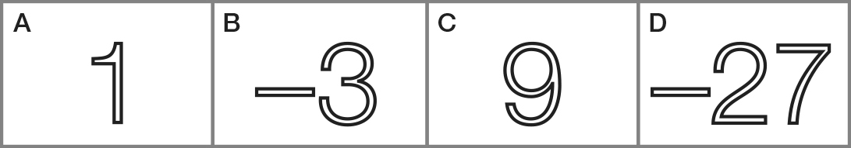

(a) 43

(b) -12

Question 35 2 marks [2.4]

Explain why -0.16 is not an integer.

Extended answer total:_________/14

TOTAL test marks: _______ / 72